Week 2 Report: Hands-on Practice in Design Engineering
Practice Exercise: Dual-Ear Mounting Bracket (Clevis Bracket)
Prepared by: Nimrah Saleem | Department of Electronic Engineering, NED University

1. Objective
This week's task focused on hands-on practice rather than theory: applying CAD modeling, design calculations, and drawing skills learned in Week 1 to a real, guided part-design exercise, and documenting the approach followed.

2. Exercise Description
The exercise involved modeling a dual-ear mounting bracket (clevis-style bracket) from a given dimensioned engineering drawing. The part consists of a base plate, two raised cylindrical ears with through-holes, and a slotted hole at the front for fastening. This is a common mechanical mounting component used to connect two parts with a pin or bolt.

3. Reference Drawing
The exercise was based on the following dimensioned reference drawing, which specifies all key dimensions in millimeters, including hole diameters, ear height, base length, and fillet radius.
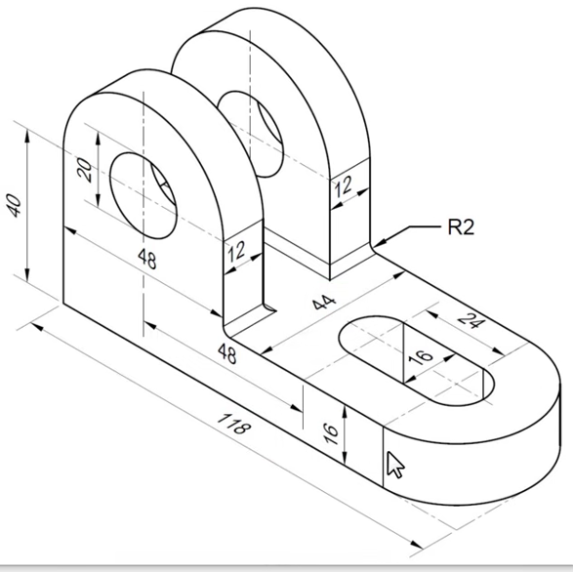
Figure 1: Reference Engineering Drawing with Dimensions (mm)

4. Approach and Steps Followed
- Studied the reference drawing to identify base dimensions (118 x 48 mm) and overall height (40 mm).
- Created the base sketch as a rectangular profile with a rounded end (R2 fillet) and extruded it to 16 mm thickness.
- Sketched and extruded the first cylindrical ear (20 mm hole, 12 mm width) on one end of the base.
- Added the second ear behind the first, offset per the 44 mm and 48 mm spacing shown in the drawing.
- Cut through-holes in both ears using the specified diameters.
- Added the slotted hole (16 x 24 mm) at the front of the base using a slot-cut feature.
- Applied fillets to sharp edges for a manufacturable, safe design.
- Verified all dimensions against the reference drawing before finalizing the model.

5. CAD Models Produced
Two versions of the bracket were modeled to practice single-ear and dual-ear configurations:
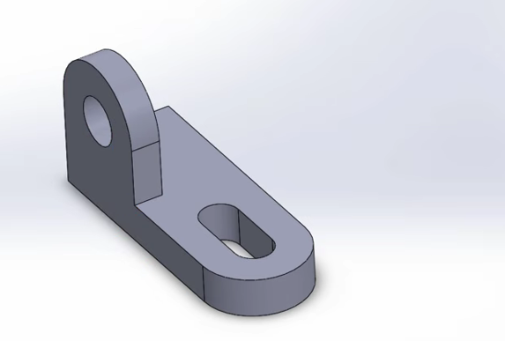
Figure 2: Single-Ear Bracket — Initial Practice Model
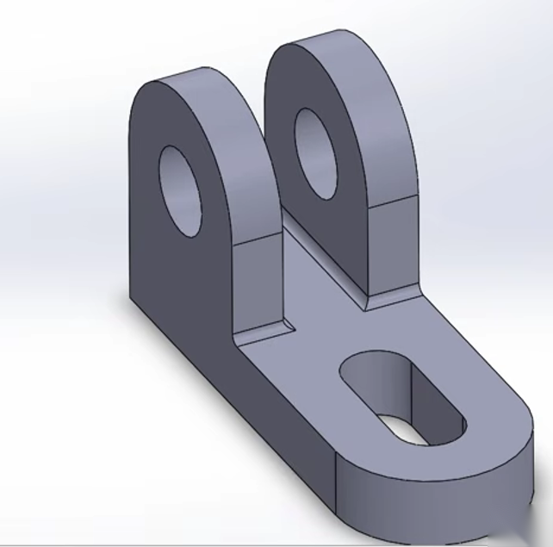
Figure 3: Dual-Ear Bracket — Final Model per Reference Drawing

6. Design Calculations
- Base volume (approx.): 118 x 48 x 16 = 90,624 mm³
- Ear hole diameter: 20 mm (upper), suitable for a standard pin/bolt fit
- Fillet radius applied: R2 mm, to reduce stress concentration at edges
- Slot hole: 16 x 24 mm, sized for bolt travel/adjustment at the mounting end

7. Outcome
The practice exercise was completed successfully, producing a dimensionally accurate CAD model matching the reference drawing. This exercise reinforced sketch-based modeling, feature creation (extrude, cut, fillet), and the importance of verifying a model against its source drawing before finalizing a design.

